[Respondent Name]  [Name of Surgery]  [Address1]  [Address2]  [City/Town]  [Postcode]  [Date] | c/o [Address1]  [Address2]  [City/Town]  [County name in full]  {NB: The format of your address is very important. It retains your full rights in law, and illustrates that this is for receipt of correspondence only and not for the benefit of Government or it’s agencies – delete note before sending}
NOTICE-OF-LIABILITY
Notice-to-Principal-is-Notice-to-Agent; Notice-to-Agent-is-Notice-to-Principal

To: [Name of Doctor/Nurse/Vaccinator/Vaccine Centre Employee, Vaccine premises Administrator/Manager and Hospital Management]

This is a Notice of Liability setting out your personal responsibilities/ liabilities for conducting experimental medical trials as a vaccinator or a member of staff that takes part in the administration and facilitation of said experimental medical trials.

You are put on notice to uphold your personal responsibilities around obtaining fully informed consent

Copy to whom it may concern

Applicable to All Successors and Assigns
From: [Full Name of relevant person]
NOTICE
It is not my intention to harass, intimidate, offend, conspire, blackmail, coerce or cause anxiety, alarm or distress. This Notice of Liability is presented with honourable and peaceful intentions and is expressly for your benefit to provide you with due process and a good faith opportunity to remedy this most serious matter.

Personal Liability
This legal and lawful notice of liability may be used as evidence in court if needed and intends to enlighten you and protect you from attracting civil and criminal liability whether domestic or international and whether in an existing court or one to be convened under Natural Law principlesin relation to your action/s and all your omissions in relation to the alleged SARS-CoV-2 pandemic and the measures that have been and or are being taken within the United Kingdom and world-wide to control its alleged spread and effect(s) including, but not limited to, the administration of experimental COVID-19/SARS-CoV-2 mRNA gene therapies injections vaccines (and or viral vector injections vaccines and or nucleodide-modified messenger RNA gene therapies injections vaccines) and the harm and death caused.

As well as being liable to pay claims for medical negligence, you could face serious criminal charges including but not limited to Wounding contrary to S.20 of the Offences against the Person Act 1861, Administering a noxious substance with intent contrary to S.23 of the Offences against the Person Act 1861, andor Manslaughter contrary to Common Law.

You may be held personally liable for and or privately liable for and or civilly and or criminally liable for participating in unlawful, illegal and or criminal activity and or for supporting crimes against humanity, genocide, bio-warfare and or failing to prevent acts so defined, including but not limited to acts that are purposely committed as part of a widespread and or systematic policy, directed against living men and women.

Covid-19 vaccines are experimental (Phase 3 trials)
COVID-19/SARS-CoV-2 mRNA gene therapiesinjectionsvaccines (and or viral vector injections vaccines and or nucleodide-modified messenger RNA gene therapies injections vaccines)are all currently in phase 3 of clinical trials which are due to end at various points throughout 2023 dependent on the vaccine concerned, understandable given that some of the technology and ingredients are being used for the first time in humans.

Notwithstanding the emergency-use authorisation for the administration of these experimental medications, the Government is only underwriting the manufacturers of these experimental medications against any liability arising from their administration; the same does not apply to Doctors, Nurses and anyone administering these medications.

Informed consent
The definition of ‘informed consent’ (for adults) is set out in the Supreme Court judgement of Montgomery v Lanarkshire (2015). See the attached document in order to ensure that you are obtaining fully informed consent.
It is your duty as a vaccinator to ensure that fully informed consent is provided by each patient before you administer the vaccine to that individual.
As you are or should be aware, the NHS should be governed by strict guidelines about informed consent, as per the Montgomery ruling, as prescribed by the General Medical Council (‘GMC’).
NHS Guidance limits the advice to be provided in relation to “informed consent” to communication of “the anticipated benefits of vaccination in the simplest of terms”, “the likely side effects from vaccination and any individual risks they may run should be addressed”, and “the disbenefits of not consenting to the vaccination”. It will be noted, then, that the stance of the NHS as regards the issue of consent is inadequate.
The GMC makes it abundantly clear to all medical practitioners operating under its banner that informed patient consent is critical for all medical processes and procedures, and that consent must be offered freely, based on adequate information, and in the absence of any form of coercion.
You must provide information about all material risks to which a reasonable person in the patient's position would attach significance. This puts the patient at the centre of the consent process, since the patient’s understanding of material risk must be considered.

The General Medical Council Guidance - Decision Making and Consent (2020)1states: Doctors MUST attempt to find out what matters to patients, so they can share information about the benefits and harms of proposed options and reasonable alternatives. The word ‘MUST’ makes this mandatory.

GMC guidance states doctors MUST address the following information:

a) The/any risk of harm that a doctor believes (or should believe) that anyone in the patient’s position would want to know.

b) The effect of the individual patient’s (personal) clinical circumstances on the probability of a benefit or harm occurring. If a patient’s medical history is known, you will know some of what you need to share already, but the dialogue could reveal more. If you do not know the patient’s medical history, the dialogue is critical.

c) Risks of harm and potential benefits that the patient would consider significant for any reason. These will be revealed during your discussion with the patient about what matters to them.

d) Any risk of serious harm, however unlikely it is to occur.

e) Expected harms, including common side-effects and what to do if they occur (i.e. as regards seeking appropriate medical intervention and signposting the Government’s ‘Yellow Card’ scheme2 (with which any medical practitioner administering an experimental vaccine is, or should be, cognizant of).

You are under a duty to tell the patient that there is limited short-term safety data and absolutelyNO long-term safety data.There is simply no evidence as topotential long-term adverse health effects.

You are under a duty to inform the patient about the reported deaths, harms and side effects: Of relevance to the issue of informed consent is theYellow Card Scheme2 which the UK Government has established. Overall, 1 in 136 people experience a ‘yellow card’ adverse event.

Serious risk of harm and death:

COVID-19 VACCINE DAMAGE – OCTOBER 2021
 | Deaths | Injuries | Date
UK | 1,738 | 1,243,998 | 22ndOctober
EU | 24,247 | 2,567,685 | 9thOctober
USA | 17,128 | 818,042 | 22ndOctober
TOTAL | 43,113 | 4,629,725

The yellow card system shows that Deathhas been listed as an outcome directly related to COVID-19 vaccines (not from any underlying health conditions) as of 22nd October, 2021 on 1,738occasions in UK. The Government and MHRA estimate this reported figure amounts at best to 10%, and at worst 1%, of the true number of the experimental vaccine-related deaths, in other words that the true figure for deaths is between 17,000 – 170,000).

As at the same date, Deafness as an outcome related to COVID-19 vaccines has increased to 1,332, and Eye disorders including Blindness as an outcome on at least 20,665 occasions.

It follows that the rates of increase of death and significant harm (excluding blood clotting/strokes/heart attacks) are increasing as the vaccination programme is rolled out. As at October22, 2021 the System shows over a million adverse reactions to the experimental vaccines (over 1.2 million injuries).

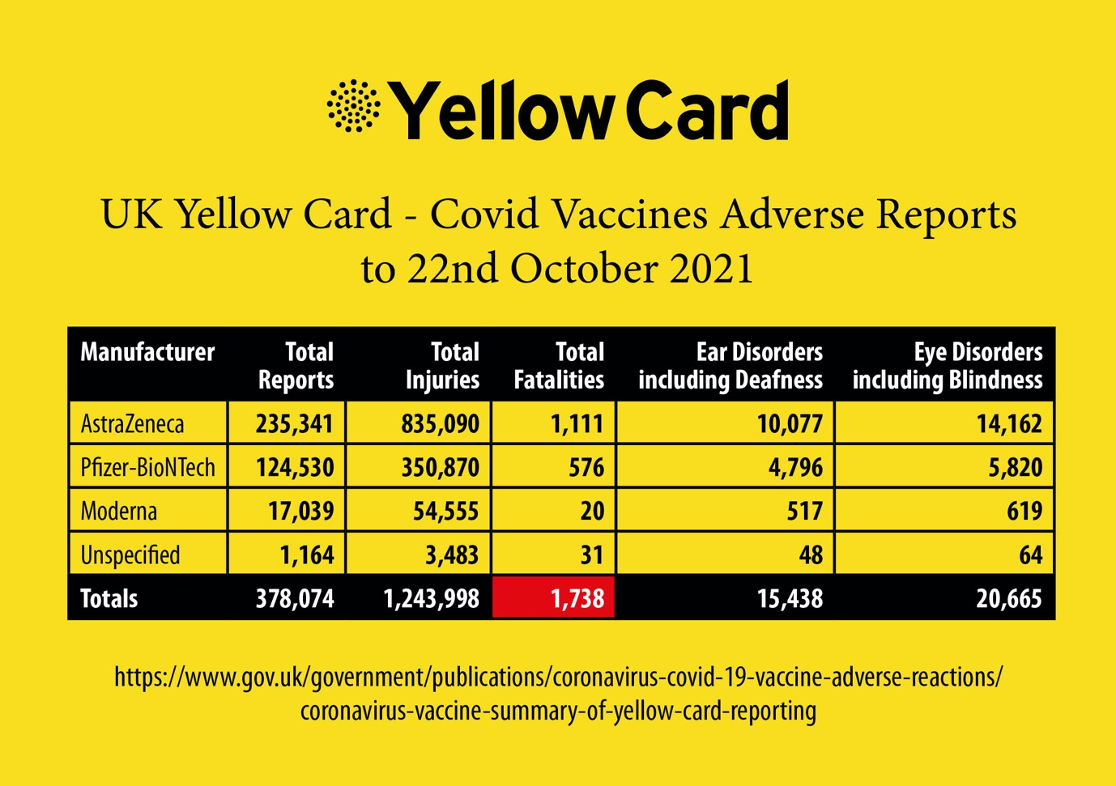

https://www.gov.uk/government/publications/coronavirus-covid-19-vaccine-adverse-reactions/coronavirus-vaccine-summary-of-yellow-card-reporting

Data from Public Health England released on the 3rd Sept 2021 shows that 67% of inpatient Covid deaths were in double jabbed, fully vaccinated people; this has increased to 78% as at 3rd October 2021. Estimates are provided as to the number of deaths said to have been avoided as a consequence of administration of the experimental vaccines but no evidential basis has been provided by the Government in support, accordingly those estimates amount to speculation. There is limited, if any, evidence that the experimental vaccines offer protection against Covid-19. They do, however,have many evidence-based risks associated with them, including death.3

Furthermore it should be noted that natural immunity appears to confer longer-lasting and stronger protection against Covid-19/SARS-CoV-2 infection, symptomatic disease and hospitalization from the Delta variant when compared to Pfizer-BioNTech’s two-dose vaccine-induced immunity.4

It should further be noted that it is accepted by the Governmentthat the experimental vaccines do not prevent transmission of Covid-19 nor do they prevent catching of the virus.

You are under a duty to tell the patient that there are potential impacts on fertility and that mRNA and RNA technologies involved in the applicable vaccines are completely novel technology and experimental,with the possibility of unanticipated/unpredictable long term/late onset health effects.

You are under a duty to tell each patient that potential cross-reactivity of vaccine-induced antibodies to virus spike protein, with the placental protein syncytin-1, could cause infertility.5

Further still, there is evidence of a risk of Antibody Dependent Enhancement causing more severe Covid-19 illness on exposure to virus post-vaccination. This is confirmed in Government publications.

On the VAERS6 USA (Vaccine Adverse Events Reporting System) Death has been listed as an outcome related to COVID-19 vaccines at least 3,924 times as of May 8, 2021 a figure which at October22, 2021 had risen to 17,619.

On the European database EudraVigilance Death has been listed as an outcome related to COVID-19 vaccines at least 27,247times as of October9, 2021 and includes 2,563,768adverse reactions.
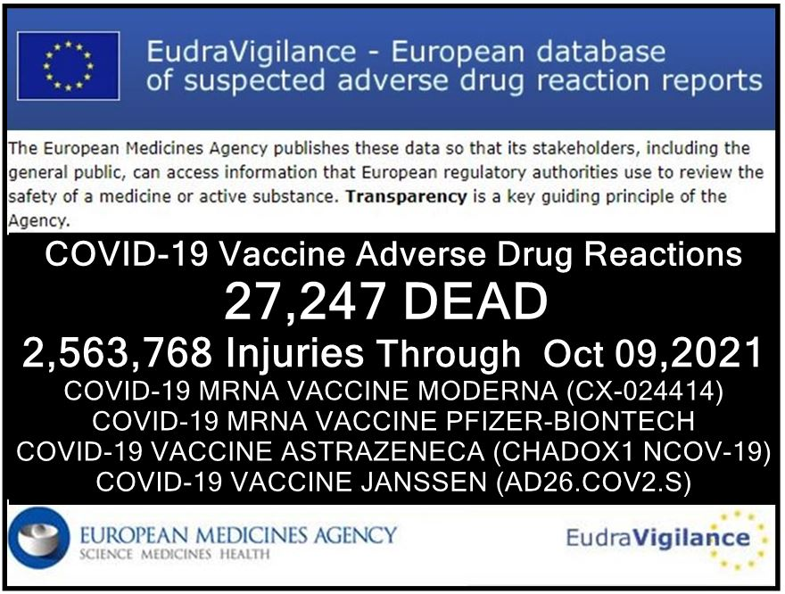

The COVID-19 vaccine development was unprecedently accelerated. Vaccine safety testing takes normally approximately 10 years. Current COVID-19 vaccines were trialled for only a few months with little/no animal testing (with all animals dying). PHASE 3 trials will notbe complete for 2 years.7

You are under a duty to tell each patient thatCOVID-19 vaccines may sensitise recipients to more severe disease.8

You are under a duty to tell each patient that there have been reports of some serious side effects, including cases of transverse myelitis and neurological conditions,even in the Astra Zeneca vaccine trial.9

You are under a duty to tell each patient that there are cases of anaphylaxis, and that the vaccine site must deal with anaphylaxis.10

You are under a duty to tell each patient that it is known that vaccines can trigger allergy and auto-immunity problems, and may be contra-indicated with pre-existing auto-immune conditions or CFS/ME, or previous vaccine injury/reactions, and of the MHRA statement in this regards: MHRA 09 December 2020 specifies thatany person with a history of anaphylaxis to a vaccine, medicine or food should not receive the Pfizer/BioNTech vaccine.

You are under a duty to tell each patient that a second dose should not be given to anyone who has experienced anaphylaxis following administration of the first dose, that any patient with a history or strong family history of allergies or auto-immune conditions may choose to refuse a Covid-19 vaccine. Doctors working with CFS/ME patients already advise them to avoid vaccination as this may trigger a relapse.11

Eachpatient’s individual risk from Covid-19 MUST be discussed, including but not limited to IFR <0.05% for <70 years to weigh up against risk of harm from vaccine, patient expectation of vaccine benefit (i.e. reducing risk of severe illness, hospitalisation and preventing infection with and transmission of SARS-Cov-2).12

Each patient MUST be made aware of the full list of vaccine ingredients if they are to be aware if they are (or might be) allergic to any ingredients in order to provide fully informed consent to the administration of any particular ingredient to which s/he is or may be allergic.
You must makeeach patient aware that current trials are not designed to show if a COVID-19 vaccine will reduce his/her risk of hospitalisation or death;nor that it willprevent infection by/from and/or transmission of the virus sincethis may well affect the risk versus benefit profile.13

You should take notice of any ethical/religious considerations, e.g. animal products - vegetarianism/veganism, WI-38 human diploid cells (aborted fetus source) - pro-life/religious belief of each patient.

Each patient MUST be made aware that the vaccine manufacturers have demanded and been granted governmental immunity from liability for injury or death caused by the vaccines.

Before a second dose, each patient must be asked about his/her reaction to the first dose. A reaction to a first dose increases the risk of a major reaction to a second dose; for example, as regards the Moderna vaccine, 100% of high-dose participants have reported systemic side effects after their second dose, some severe.

A full list of adverse reactions should be shared, including (but not limited to) the common side-effects such as chills, fever, myalgia, fatigue, arthralgia, headache, and pain at the injection site.14

You are also under a duty to take reasonable care to ensure that each patient is aware of any reasonable alternative or variant treatments, namely that:
- Vitamin D, 5,000iu daily, has proven benefit to prevent and treat Covid-19;
- Vitamin C, 5 grams daily, has proven benefit to prevent and treat Covid-19;
- Topical antiseptics (such as iodine) are of proven benefit to reduce the loading dose, and hence disease severity, of Covid-19;
- Ivermectin and Hydroxychloroquine are available alternative medications for prophylaxis and or treatment of COVID-19. Individual medical practitioners who are licensed to prescribe Ivermectin, for example, have been advised by the MHRA in writing that they are permitted to do so if their clinical judgment is such that this is an appropriate course to take have undertaken the appropriate clinical assessment of a patient.

It is negligent not to make all of the aforementioned information available to any person in relation to his/her provision of informed consent.

Consent given without being informed by the administrator
The Nuremberg Code15 first principle provides that medical experiments or trials require voluntary and informed consent of all participants.
Obtaining informed consent involves ensuring that the patient,before s/heis vaccinated,is provided with adequate information in order to make an INFORMED choice whether to have administered the medication that is being offered.
It is clear that most patients are not providing informed consent since very limited information is being provided to them in order to enable them to be “informed”. They are, therefore, consenting without sufficient information being provided by the doctor or other administrator of the experimental vaccine.
Patients are largely unaware of the “Yellow Card” scheme or the figures (including Government estimates as to true figures) reported within it, nor indeed how to access the data.
The Government and relevant organisations which report to it, in conjunction with the use of main stream media and through social media, has placed pressure on individuals, their employers, businesses and their venues, airlines, imposition of international travel restrictions, and as regards children the use of celebrities seeking to normalise the administration of experimental vaccines, to believe that without the such medication individuals’ ability to undertake lawful activities will be restricted unless they agree to receive the experimental vaccines. This is coercion.Consent MUST be given freely without coercion: otherwise it is invalid and you may be guilty of an offence.

Other Important Facts
Some of the COVID-19 vaccines are using, for the first time in humans, mRNA (messenger RNA) technology, which a recently-published Harvard University study concludes can alter a person’s DNA, contrary to denials of this by the manufacturers that this is the case and asserting that such suggestions are ‘conspiracy theory’.16

Under 18’s
There have now been reported deaths as well as serious side effects within children in UK as well as abroad. 86% of children suffered an adverse reaction to the “Pfizer Covid-19 vaccine” in clinical trials in the USA.17
Fewer children worldwide have died from COVID-19 itself (recorded as death due to a positive result, with or without symptoms, and where underlying health conditions were present and often the cause of death) than those who have died from side-effects from the experimental vaccines. The most common side effects are neurological disorders, blood coagulation/clots and thromboembolic events such as pulmonary embolisms.

Absent emergency authorisation which is being used by the UK Government and others around the world to roll out the experimental vaccines, these medications would have to be withdrawn from the “market”. In the USA, for example, deaths in relation to other vaccines numbering as few as 50 (in a country with a population in excess of 360 million) would cause withdrawal of the relevant medication. Comparable provisions apply in the UK and in Europe. This too is something directly relevant to informed consent.

There is a wider acknowledged link to heart conditions (myocarditis/ myopericarditis and pericarditis) in young men and boys globally, in the US the VAERS reporting system (as of 22ndOctober) has captured 893 reports of myocarditis/myocardial infections and diseases & pericarditis/pericardial infections and diseases for age 6-17 year olds6 and 2,236 for age 18-29 year olds6 grand total for all ages of 10,954* (* see chart below).

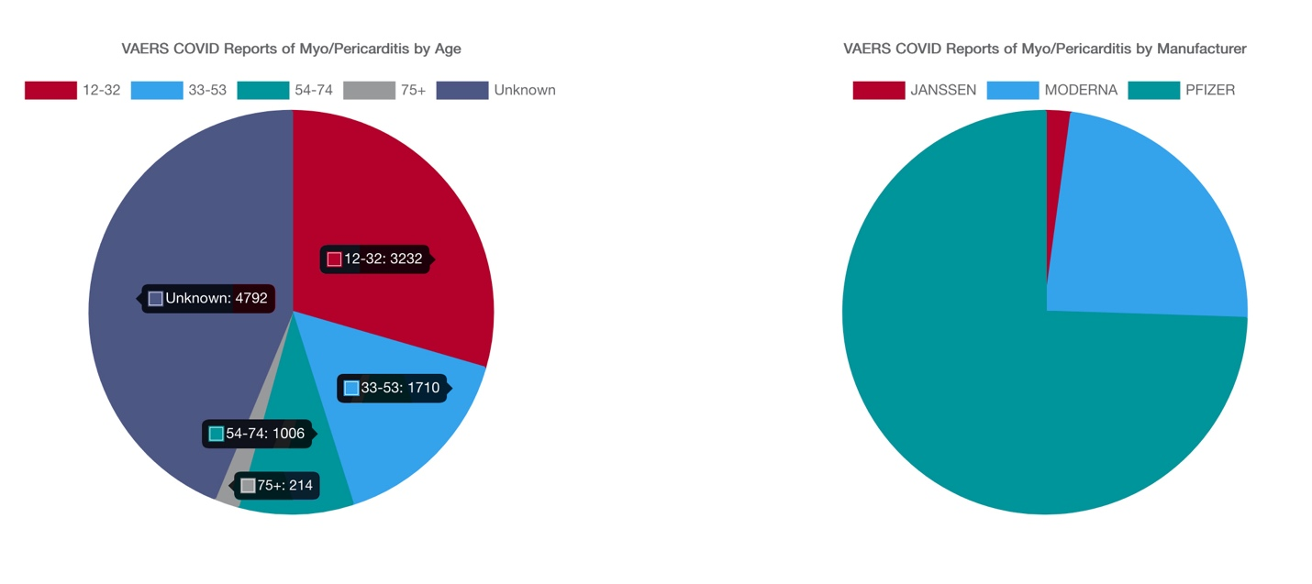

The US Food and Drug Administration (FDA) documentation acknowledges that in the case of the Pfizer-BioNTech “There is no information on the co-administration of the Pfizer-BioNTech COVID-19 Vaccine with other vaccines”.19 Therefore the risks and potential harm arising from co-administration with say HPV or Influenza “Flu” vaccines for example are unquantified at this time.

As you are undoubtedly aware, children under the age of 16 can sometimes be deemed “Gillick competent” (for example, a 15 year old girl seeking the contraception pill without her parents’ knowledge) but in relation to experimental medications such as these COVID-19 vaccines which have no long-term data known and where deaths and serious adverse reactions are recorded but not known to the child prior to their “consent” it would be absurd to claim that they were in fact “Gillick competent”. The Court of Appeal case of Bell v Tavistock [2021]20 makes clear that children under 16 years of age need to be deemed Gillick competent by the treating clinician if receiving an experimental medication where the long-term effects may not be clear to the child, the case specifically concerning puberty blockers. Clearly this case means that each child would need to be assessed by the treating clinician as to their informed consent i.e. their understanding of the harm and long-term effects before being given such treatment and of alternative treatments available etc. The case does not amend the Supreme Court judgement of Montgomery v Lanarkshire (2015)21 which sets out what informed consent is.
The case of AC v CD & Others [202122 makes it clear that the absence of Gillick competency cannot then be used to allow parents to consent to a child having an experimental medication when the child him/herself does not want it. The law therefore is protective of children under 16 years of age when it comes to experimental medications, as responsible parents should expect, and recognises children’s limitations regarding being “informed”.

Efficacy of Vaccines
The efficacy of the vaccines in adults have been exaggerated by the pharmaceutical companies, as reported in the medical journal, The Lancet23;
“Vaccine efficacy is generally reported as a relative risk reduction (RRR). It uses the relative risk (RR)—ie, the ratio of attack rates with and without a vaccine—which is expressed as 1–RR. Ranking by reported efficacy gives relative risk reductions of 95% for the Pfizer–BioNTech, 94% for the Moderna–NIH, 90% for the Gamaleya, 67% for the J&J, and 67% for the AstraZeneca–Oxford vaccines. However, RRR should be seen against the background risk of being infected and becoming ill with COVID-19, which varies between populations and over time. Although the RRR considers only participants who could benefit from the vaccine, the absolute risk reduction (ARR), which is the difference between attack rates with and without a vaccine, considers the whole population. ARRs tend to be ignored because they give a much less impressive effect size than RRRs: 1·3% for the AstraZeneca–Oxford, 1·2% for the Moderna–NIH, 1·2% for the J&J, 0·93% for the Gamaleya, and 0·84% for the Pfizer–BioNTech vaccines.”

Further information on alternative medicines
Alternative treatments for COVID-19 have been proved to be safe and effective. Hydroxychloroquine, Remdesivir have both shown positive results, as have preventative medicines, minerals and vitamins like Vitamin C, Vitamin D, D3, Zinc, Magnesium and Selenium, and there natural equivalents which have all helped people from developing any kinds of respiratory illness.

The above aside, there have not been other treatments that have been demonstrated to reduce the burden of morbidity and mortality from COVID-19. Although corticosteroids have been proven to reduce mortality in severe disease, there has been little convincing evidence on interventions that may prevent disease, reduce hospitalizations, and reduce the numbers of people progressing to critical disease and death.

Ivermectin (disparaged in mainstream media but a World Health Organisation recognized essential medicine), at the usual doses (0.2–0.4 mg/kg), is considered extremely safe for use in humans: in addition to its antiparasitic activity, it has been noted to have antiviral and anti-inflammatory properties, leading to an increasing list of therapeutic indications. A review by the Front Line COVID-19 Critical Care Alliance summarized findings from 27 studies on the effects of Ivermectin for the prevention and treatment of COVID-19 infection, concluding that ivermectin “demonstrates a strong signal of therapeutic efficacy” against COVID-19.9 Another recent review found that Ivermectin reduced deaths by 75%.

Conclusion
Principle 5 of the Nuremberg Code15states that no medical experiments or trials should be conducted where there is an a priori (theoretical) reason to believe that death or disabling injury will occur. You will appreciate that these medical experiments (the trials for which conclude in 2023) are not theoretical as regards death or disabling injury: there is clear evidence of both arising. There is still no information being given to people about the full ingredient list/ content of these experimental medications nor what effects these may have combined and individually. A “wait and see” approach is not allowing patients to make informed decisions in advance of being given the COVID-19 vaccine.

Receipt of this notice shows that you have been made aware that death or other serious injuries are possible outcomes for taking the COVID-19 experimental vaccinations and that you are liable for any harm or death where you have not obtained informed consent in advance of injecting any patient under your duty of care.

Given the clear evidence that serious harm (or worse) can and does arise as a consequence of these experimental injections, the vaccinator (whether part of management, Consultant, Doctor, Nurse, vaccination premises employee or any other member of staff) involved in the process of administration of Covid-19 vaccinations, renders themselves liable to criminal prosecution for wounding/administering a noxious substance or worse if death results before the domestic courts, in addition to liability for prosecution before the International Criminal Court for breaches of the Nuremberg Code. This is quite separate to any civil liability that arises, or any prosecution for offences contrary to common law.

Cited References;

- https://www.gmc-uk.org/ethical-guidance/ethical-guidance-for-doctors/decision-making-and-consent)
- YELLOW CARD SYSTEM REPORTS (UK)
  - Website of vaccine reported adverse events - https://coronavirus-yellowcard.mhra.gov.uk
  - Sample of Pfizer reported adverse events - https://assets.publishing.service.gov.uk/government/uploads/system/uploads/attachment_data/file/986035/DAP_Pfizer_050521.pdf
  - Sample of Astra Zeneca reported adverse events - https://assets.publishing.service.gov.uk/government/uploads/system/uploads/attachment_data/file/986033/DAP_AstraZeneca_050521.pdf
  - Sample of Moderna reported adverse events - https://assets.publishing.service.gov.uk/government/uploads/system/uploads/attachment_data/file/986034/DAP_Moderna_050521.pdf
  - Sample of unspecified reported adverse events - https://assets.publishing.service.gov.uk/government/uploads/system/uploads/attachment_data/file/986036/DAP_Unspecified_050521.pdf

- Public Health England SARS-CoV-2 variants of concern and variants under investigation in England Technical briefing 22, 3 September 202.
- https://www.medrxiv.org/content/10.1101/2021.08.24.21262415v1
- https://doi.org/10.1111/ijcp.13795
- VAERS REPORT (USA)
Run your own report to check results here by clicking link below and follow instructions:
https://wonder.cdc.gov/vaers.html
Instructions for use
Click ‘I agree
Click ‘Data Report’
Choose from section 1. ‘Group results by - Vaccine manufacturer’
Choose from section 3. ‘Vaccine products - Covid 19 vaccines’
Choose from section 5. ‘Event category - Death’
Scroll to bottom of page and press ‘Send’
View latest data for deaths reported from Covid Vaccines grouped by Vaccine manufacturer
- https://www.bmj.com/content/370/bmj.m3096/rr
- https://www.bulatlat.com/2020/08/21/hazards-of-the-covid-19-vaccine/
- Astra Zeneca Transverse Myelitis report
https://www.nature.com/articles/d41586-020-02594-whttps://www.nytimes.com/2020/09/19/health/astrazeneca-vaccine-safety-blueprints.html
- The CDC identified 6 case reports of anaphylaxis following Pfizer-BioNtech vaccine meeting ;Brighton Collaboration criteria for anaphylaxis;CDC updated advice on equipment necessary at all vaccination sites to deal with anaphylaxis
Anaphylaxis reports:
https://www.cdc.gov/vaccines/acip/meetings/downloads/slides-2020- 12/slides-12-19/05-COVID-CLARK.pdf
Preparations to manage anaphylaxis vaccine recipients:
https://www.cdc.gov/vaccines/covid-19/info-byproduct/pfizer/anaphylaxis-management.html
- https://www.gov.uk/government/news/confirmation-of-guidance-tovaccination-centres-on-managing-allergic-reactions-following-covid-19-vaccination-with-the-pfizer-biontech-vaccine
- Covid-19 IFR estimate by age (Table 2):
https://spiral.imperial.ac.uk:8443/bitstream/10044/1/83545/8/2020-10-29-COVID19-Report-34.pdf
- https://www.bmj.com/content/371/bmj.m4037
- https://www.nejm.org/doi/full/10.1056/NEJMoa2022483
- The ten points of the Nuremberg Code
The ten points of the code were given in the section of the judges' verdict entitled "Permissible Medical Experiments"
The voluntary consent of the human subject is absolutely essential.
The experiment should be such as to yield fruitful results for the good of society, unprocurable by other methods or means of study, and not random and unnecessary in nature.
The experiment should be so designed and based on the results of animal experimentation and a knowledge of the natural history of the disease or other problem under study that the anticipated results will justify the performance of the experiment.
The experiment should be so conducted as to avoid all unnecessary physical and mental suffering and injury.
No experiment should be conducted where there is an a priori reason to believe that death or disabling injury will occur; except, perhaps, in those experiments where the experimental physicians also serve as subjects.
The degree of risk to be taken should never exceed that determined by the humanitarian importance of the problem to be solved by the experiment.
Proper preparations should be made and adequate facilities provided to protect the experimental subject against even remote possibilities of injury, disability, or death.
The experiment should be conducted only by scientifically qualified persons. The highest degree of skill and care should be required through all stages of the experiment of those who conduct or engage in the experiment.
During the course of the experiment the human subject should be at liberty to bring the experiment to an end if he has reached the physical or mental state where continuation of the experiment seems to him to be impossible.
During the course of the experiment the scientist in charge must be prepared to terminate the experiment at any stage, if he has probable cause to believe, in the exercise of the good faith, superior skill and careful judgment required of him that a continuation of the experiment is likely to result in injury, disability, or death to the experimental subject.
https://en.wikipedia.org/wiki/Nuremberg_Code
- ‘SARS-CoV-2 RNA reverse-transcribed and 1 integrated into the human genome’, 13/12/2020.
- https://dailyexpose.co.uk/2021/05/30/shocking-86-of-children-suffered-an-adverse-reaction-to-the-pfizer-covid-vaccine-in-clinical-trial/; (https://www.afinalwarning.com/522797.html).
- Myopericarditis following COVID-19 vaccination: Updates from the Vaccine Adverse Event Reporting System (VAERS) [Aug 30, 2021] https://www.cdc.gov/vaccines/acip/meetings/downloads/slides-2021-08-30/03-COVID-Su-508.pdf
- FDA Pfizer-BioNTech information: https://www.fda.gov/media/144413/download
- Court of Appeal case of Bell v Tavistock [2021] https://www.judiciary.uk/wp-content/uploads/2021/09/Bell-v-Tavistock-judgment-170921.pdf
- https://www.supremecourt.uk/cases/docs/uksc-2013-0136-judgment.pdf
- AC v CD & Others [2021] https://www.bailii.org/ew/cases/EWHC/Fam/2021/741.html
- COVID-19 vaccine efficacy and effectiveness—the elephant (not) in the room - https://www.thelancet.com/journals/lanmic/article/PIIS2666-5247(21)00069-0/fulltext

OTHER SUPPORTING REFERENCES

“NHS England draws up plan to give Covid jabs to children 12 and over;
Contingency planning in place to vaccinate secondary school pupils at start of new academic year”
https://www.theguardian.com/world/2021/may/02/nhs-england-draws-up-plan-to-give-covid-jabs-to-children-12-and-over

“The ongoing phase III trials for covid-19 vaccines are some of the most consequential randomised trials ever done.”.....“The covid-19 vaccine protocols should be scrutinised by the widest possible readership, to open a critical discussion of many questions about their design and conduct. These include why children, immunocompromised people, and pregnant women have been excluded from most trials; whether the right primary endpoint has been chosen; whether safety is being adequately evaluated; and whether gaps in our understanding of the clinical implications of pre-existing T cell responses to SARS-CoV-2 are being addressed.11”
https://www.bmj.com/content/371/bmj.m4058

“Following extensive pre-clinical testing, this next phase of the trial will allow us to refine our innovative, self-amplifying RNA vaccine for the first time in humans.”
https://www.imperial.ac.uk/covid-19-vaccine-trial/

https://2020news.de/en/dr-wodarg-and-dr-yeadon-request-a-stop-of-all-corona-vaccination-studies-and-call-for-co-signing-the-petition/

COVID-19 VACCINATION CONSENT FORM
(including additional questions for those under 18 years of age)

Purpose:
This form has been designed to support the Informed Consent process for Covid-19 vaccinations.
FOR THE LEGAL ADMINISTRATION OF ANY CV19 VACCINE, BOTH PARTIES MUST READ AND SIGN THIS DOCUMENT

Audience:
• Doctors (or their delegated Health Care Professionals)
• Patients receiving Covid-19 Vaccine

Background:
This document is based on the Montgomery Judgement and GMC Guidelines.

The Montgomery Judgement and Informed Consent
https://www.themdu.com/guidance-and-advice/guides/montgomery-and-informed-consent
This Supreme Court judgement of Montgomery v Lanarkshire (2015) changed the standards of consent. The key passages from Montgomery Judgement state:

“...The doctor is therefore under a duty to take reasonable care to ensure that the patient is aware of any material risks involved in any recommended treatment, and of any reasonable alternative or variant treatments....”

“The test of materiality is whether, in the circumstances of the particular case, a reasonable person in the patient's position would be likely to attach significance to the risk, or the doctor is or should reasonably be aware that the particular patient would be likely to attach significance to it.”

Before Montgomery, a doctor's duty to warn patients of risks was based on whether they had acted in line with a responsible body of medical opinion - known as the “Bolam test”. Now, doctors must provide information about all material risks to which a reasonable person in the patient's position would attach significance. This puts the patient at the centre of consent process, as their understanding of material risk must be considered. Both patient and doctor need to sign this document. If doctors fail to properly discuss the risks and alternative treatments with the patient, this renders them personally responsible for damages. This document therefore protects the patient and the doctor.
General Medical Council Guidance - Decision Making and Consent (2020)
(https://www.gmc-uk.org/ethical-guidance/ethical-guidance-for-doctors/decision-making-and-consent )
This states that doctors MUST attempt to find out what matters to patients, so they can share information about the benefits and harms of proposed options and reasonable alternatives. Note the word MUST makes this a legally binding directive. GMC Guidance states doctors MUST address the following information:
a) Recognise risks of harm that you believe anyone in the patient’s position would want to know. You’ll know these already from your professional knowledge and experience.
b) The effect of the patient’s individual clinical circumstances on the probability of a benefit or harm occurring. If you know the patient’s medical history, you’ll know some of what you need to share already, but the dialogue could reveal more.
c) Risks of harm and potential benefits that the patient would consider significant for any reason. These will be revealed during your discussion with the patient about what matters to them.
d) Any risk of serious harm, however unlikely it is to occur.
e) Expected harms, including common side effects and what to do if they occur.

References

Vitamin D | Vitamin C | Iodine
1. https://www.researchsquare.com/article/rs-21211/v1  2. https://www.ncbi.nlm.nih.gov/pmc/articles/PMC7513835  3. https://www.grassrootshealth.net/wp-content/uploads/2020/04/Grant-GRH-Covid-paper-2020.pdf  4. https://www.bmj.com/content/356/bmj.i6583 | 1. http://orthomolecular.org/resources/omns/v16n25.sHtml  2. https://orthomolecular.activehosted.com/index.php  3. https://ccforum.biomedcentral.com/articles/10.1186/s13054-020-03249-y  4. https://www.ncbi.nlm.nih.gov/pmc/articles/PMC7592143/ | 1. https://papers.ssrn.com/sol3/papers.cfm?abstract_id=3563092  2. https://www.medrxiv.org/content/10.1101/2020.05.25.20110239v1  3. https://www.researchgate.net/publication/34076984  4. Iodine_Intake_to_Reduce_Covid-19_Transmission_and_Mortality  https://www.medrxiv.org/content/10.1101/2020.09.07.20180448v1

Vaccine development & testing timeframes:
“The discovery and research phase is normally two-to-five years, according to the Wellcome Trust. In total, a vaccine can take more than 10 years to fully develop”
https://www.weforum.org/agenda/2020/06/vaccine-development-barriers-coronavirus/
Vaccines trigger post viral syndromes:
“We present epidemiological, clinical and experimental evidence that ME/CFS constitutes a major type of adverse effect of vaccines” (2019 paper)
https://www.sciencedirect.com/science/article/abs/pii/S1568997219301090
Allergy and autoimmunity effects of vaccines:
1. Shoenfeld Y et al - Vaccination and autoimmunity - Vaccinosis: A dangerous liaison? J Autoimun2000;14:1-10.  2. Nossal GJV - Vaccination and autoimmunity. JAI 2000;14:15-22.  3. Shoenfeld Y et al - Vaccination as an additional player in the mosaic of autoimmunity. Clin Exp Rheumatol 2000;18  4. Rogerson SJ. Nye FJ - Hepatitis B vaccine associated with erythema nodosum and polyarthritis. BMJ 1990;301:345.  5. Haschulla E et al - Reactive arthritis after hepatitis B vaccination. J Rheumatol1990;17:1250-1251.  6. Biasi D et al - A new case of reactive arthritis after hepatitis B vaccination. Clin Exp Rheumatol1993;11:215.  7. Gross K et al - Arthritis after hepatitis B vaccination. Report of three cases. Scand J Rheumatol1995;24:50-52.  8. Maillefert JF et al - Rheumatic disorders developed after hepatitis B vaccination. Rheumatology (Oxford) 1999;38:978-983 | 9. Grasland A et al - Adult-onset Still's disease after hepatitis A and B vaccination (article in French). Rev Med Interne 1998;19:134-136.  10. Pope JE et al - The development of rheumatoid arthritis after recombinant hepatitis B vaccination. J Rheumatol1998;25:1687-1693.  11. Guiseriz J - Systemic lupus erythematosus following hepatitis B vaccine. Nephron 1996;74:441.  12. Grezard P et al - Lupus erythematosus and buccal aphthosis after hepatitis B vaccination in a 6-yearold child. Ann Dermatol Vener1996;123:657-659.  13. Weibel RE et al - Chronic arthropathy and musculoskeletal symptoms associated with rubella vaccines. A review of 124 claims submitted to the National Vaccine Injury Compensation Program. Arthritis Rheum 1996;39:1529-1534.  14. Ray P et al - Risk of chronic arthropathy among women after rubella vaccination. Vaccine Safety Datalink Team. JAMA 1997;278:551-556.  15. Howson CP et al - Adverse events following pertussis and rubella vaccines. Summary of a report of the Institute of Medicine. JAMA 1992;267;392-396. | 16. Howson CP et al - Chronic arthritis after rubella vaccination. Clin Infect Dis 1992;15:307-312.  17. Mitchell LA et al - HLA-DR class II associations with rubella vaccine-induced joint manifestations. J Infect Dis 1998;177:5-12.  18. Nussinovitch M, Harel L, Varsano I. Arthritis after mumps and measles vaccination. Arch Dis Child 1995;72:348-349.  19. Thurairajan G et al Polyarthropathy, orbital myositis and posterior scleritis: an unusual adverse reaction to influenza vaccine. Br J Rheumatol1997;36:120- 123.  20. Maillefert JF et al - Arthritis following combined vaccine against diphtheria, polyomyelitis and tetanus toxoid. Clin Exp Rheumatol2000;18:255-256.  21. Adachi JA et al - Reactive arthritis associated with typhoid vaccination in travelers: report of two cases with negative HLA-B27. J Travel Med 2000;7:35-36.  22. Older SA et al - Can immunization precipitate connective tissue disease? Report of five cases of systemic lupus erythematosus and review of the literature. Sem Arthritis Rheum 1999;29:131-139
References
With respect to the new COVID-19 vaccinations the Doctor MUST inform the patient of the following and tick the box to indicate such:

Montgomery Judgement & GMC Guidance | Facts | Notes | Discussed
2015 Montgomery Judgement on Informed Consent | The doctor is therefore under a duty to take reasonable care to ensure that the patient is aware of .......... any reasonable alternative or variant treatments. | Vitamin D, 5,000iu daily has proven benefit to prevent and treat Covid-19  Vitamin C, 5 grams daily has proven benefit to prevent and treat Covid-19  Topical antiseptics (such as iodine) are of proven benefit to reduce the loading dose, and hence disease severity, of Covid-19  Ivermectin and Hydroxychloroquine are available alternative medications for prophylaxis and or treatment of COVID-19.  Individual medical practitioners who are licensed to prescribe Ivermectin, for example, have been advised by the MHRA in writing that they are permitted to do so if their clinical judgment is such that this is an appropriate course to take have undertaken the appropriate clinical assessment of a patient. | Yes/no
GMC Guidelines to Doctors | Facts | Notes | Discussed
a. Recognised risks of harm that you believe anyone in the patient’s position would want to know. You’ll know these already from your professional knowledge and experience. | Limited short-term safety data: NO long-term  safety data available on current CV-19 vaccines,  including potential impacts on fertility.  mRNA vaccines are a completely novel  technology - essentially experimental, with the possibility of unanticipated/unpredictable long term/late onset health effects  Risk of Antibody Dependent Enhancement causing more severe Covid-19 illness on exposure to virus post-vaccination | CV-19 vaccine development accelerated. Vaccine safety testing normally c.10 years. Current CV-19 vaccines trialled for a few months with little/no animal testing. PHASE 3 trials won’t complete for 2 years  https://www.bmj.com/content/370/bmj.m3096/rr  https://www.bulatlat.com/2020/08/21/hazards-of-the-covid-19-vaccine/  CV-19 vaccines may sensitise recipients to more severe disease  https://doi.org/10.1111/ijcp.13795  Potential cross-reactivity of vaccine-induced antibodies to virus spike protein, with the placental protein syncytin-1, could cause infertility  https://2020news.de/en/dr-wodarg-and-dr-yeadon-request-a-stop-of-all-corona-vaccination-studies-and-call-for-co-signing-the-petition/ | Yes/no
 | There have been reports of some serious side effects including 2 cases of transverse myelitis and neurological conditions in the Astra Zeneca vaccine trial. | Astra Zeneca Transverse Myelitis report  https://www.nature.com/articles/d41586-020-02594-w  https://www.nytimes.com/2020/09/19/health/astrazeneca-vaccine-safety-blueprints.html | Yes/no
GMC Guidelines to Doctors | Facts | Notes | Discussed
continued | The CDC identified 6 case reports of anaphylaxisfollowing Pfizer-BioNtech vaccine meeting  Brighton Collaboration criteria for anaphylaxis  CDC updated advice on equipment necessary atall vaccination sites to deal with anaphylaxis | Anaphylaxis reports:  https://www.cdc.gov/vaccines/acip/meetings/downloads/slides-2020- 12/slides-12-19/05-COVID-CLARK.pdf  Preparations to manage anaphylaxis vaccine recipients:  https://www.cdc.gov/vaccines/covid-19/info-byproduct/pfizer/anaphylaxis-management.html | Yes/no
b. The effect of the patient’s individualclinical circumstances on the probability ofa benefit or harm occurring.  If you knowthe patient’s medical history, you’ll knowsome of what you need to share already,but the dialogue could reveal more. | It is known that vaccines can switch on allergy  and autoimmunity.  May be contraindicated with pre-existing autoimmune conditions or CFS/ME, or previous vaccine injury/reactions.  MHRA 09 December 2020: Any person with a history of anaphylaxis to a vaccine, medicine or food should not receive the Pfizer/BioNTechvaccine.  A second dose should not be given to anyone who has experienced anaphylaxis following administration of the first dose | Any patient with a history or strong family history of allergies or  autoimmune conditions may choose to refuse a CV-19 vaccine. Doctors working with CFS/ME patients already advise them to avoid vaccination as this may trigger a relapse.  https://www.gov.uk/government/news/confirmation-of-guidance-tovaccination-centres-on-managing-allergic-reactions-following-covid-19-vaccination-with-the-pfizer-biontech-vaccine | Yes/no
c. Risks of harm and potential benefits that the patient would consider significant for any reason. These will be revealed during your discussion with the patient about what matters to them. | Patient’s individual risk from Covid-19 MUST be discussed – IFR <0.05% for <70 years to weigh up against risk from vaccine. Patient expectation of vaccine benefit i.e. reducing risk of severe illness, hospitalisation and preventing infection with and transmission of SARS-Cov-2 Patients MUST be made aware of the full list of vaccine ingredients | Covid-19 IFR estimate by age (Table 2):  https://spiral.imperial.ac.uk:8443/bitstream/10044/1/83545/8/2020-10-29-COVID19-Report-34.pdf  Make patient aware that current trials are not designed to show if CV-19 vaccine will reduce their risk of hospitalisation or death or will prevent infection and transmission of virus as may affect risk v benefit profile  https://www.bmj.com/content/371/bmj.m4037  Ethical/religious considerations e.g. animal products - vegetarianism/veganism, WI-38 human diploid cells (aborted fetus source) - pro-life/religious belief | Yes/no

GMC Guidelines to Doctors | Facts | Notes | Discussed
d. Any risk of serious harm, however unlikely it is to occur. | The Doctor MUST consider the significance that the Patient may place on risk of material harm.  Patient MUST be made aware that the vaccine manufacturers have demanded and been granted immunity from liability for injury or death caused by the vaccines | One example may be if a patient has first-hand knowledge of a relative who has suffered serious harm following vaccination.  https://www.gov.uk/government/consultations/distributing-vaccines-and-treatments-for-covid-19-and-flu/outcome/government-response-consultation-on-changes-to-the-human-medicines-regulations-to-support-the-rollout-of-covid-19-vaccines#extending-immunity-from-civil-liability | Yes/no
e. Expected harms, including common side effects and what to do if they occur. | Full list of adverse reactions in insert to be shared. Common side-effects include chills, fever, myalgia, fatigue, arthralgia, headache, and pain at the injection site.  A reaction to the first dose increases risk of a major reaction to a second dose | Moderna vaccine -100% of high-dose participants report systemic side effects after second dose, some severe  https://www.nejm.org/doi/full/10.1056/NEJMoa2022483  Before a second dose, the patient must be asked about their reaction to the first dose. | Yes/no

To be signed by both parties and a copy held by both parties for at least 7 years.

Doctor confirmation:
I confirm that I have discussed the above issues at length with the patient below, in accordance with the 2015 Montgomery Judgement and GMC Guidelines, including:
- The fact the JCVI does not support the experimental Covid-19 vaccine rollout to children,
- The fact that the JCVI has advised parents and those aged 12 – 15 years to wait for 6 months before considering whether to receive an experimental Covid-19 vaccine in order for there to be sufficient data available to render any consent provided informed,
- Obtaining consent from each parent, guardian or anyone with parental responsibility for a child.
- For a boy or girl, exclusion of peer, celebrity, social or school pressure.
- Exclusion of the influence of one parent’s views as against another’s (whether in favour of or against the COVID-19 vaccine).

I understand that failure to correctly and fully inform my patient renders me personally and legally responsible for any damages.
Date and Time
Name of doctor or Nurse
administrating
Professional number of doctor
(GMC) or nurse (GNC)
Name of vaccine, batch number
and date of administration
Signature

Patient consent:
I confirm that I have discussed the above issues at length with the doctor or health professional above. I accept that I have been correctly informed of possible side effects of the Covid-19 vaccine and the alternatives to vaccination. I choose and consent to receive the Covid-19 vaccination.
Date and Time
Name of Patient
Name of parent or guardian if consenting on behalf of a child
Contact phone number or email
Signature

